Lap around Video Indexer:   
AI-based metadata extraction on Azure

**Technical workshop**

# Abstract and learning objectives

At the end of this workshop you will have a good understanding of the kind of information that can be extracted from video and audio content, you will be more prepared to identify opportunities related to content intelligence, pitch video AI on Azure, and demo several scenarios on Video Indexer.

This workshop will go over:

* Getting started with the Video Indexer
* Searching for video insights within a catalog
* Reviewing video insights on a specific video
* Uploading and Indexing a new video
* Embedding a video insights widget
* Editing a video to identify highlights
* Getting started with Video Indexer API

There is much more you can do with VideoIndxer and that is not included in this workshop, including customizing the catalog vocabulary, brands and faces, updating the video transcript, integration with Flow and connecting to an Azure subscription.

# Requirements

1. Internet connection
2. Internet browser
3. User account (preferably corporate)

# Overview

## What is Video Indexer?

Video Indexer (VI) is a key platform element of the Azure video AI and media stories. VI accelerates the creation of solutions that take advantage of video AI by using **deep-learning technology to extract advanced insights from video and audio files**: spoken words, faces, celebrity and custom face identification, objects, sentiments, brands and more.

VI includes a **REST API** that developer can use to build custom solutions, as well as **widgets** that can be directly embedded into customer applications, and a **web-based experience** that can be used to explore the possibilities of the service as well as be used as a management tool to customize it and connect it to Azure account.

## What is the opportunity for the customer (use cases)?

Video Indexer delivers a content intelligence report that customers can use immediately to enhance existing experiences - like improving experiences related to search or accessibility, however, this new dimension on the knowledge available to the customers will also enable them to unlock new innovations both in the user experience and business models. Here you have several use cases of existing customers using Video Indexer

* **Search** – Insights extracted from the video can be used to enhance the search experience across a video library. For example, indexing spoken words and faces can enable the search experience of finding moments in a video where a person spoke certain words or when two people were seen together. Search based on such insights from videos is applicable to news agencies, educational institutes, broadcasters, entertainment content owners, enterprise LOB apps and in general to any industry that has a video library that users need to search against.
* **Content-based Recommendation** – Insights extracted from the video can also be used to provide deep content-based recommendations. For example: recommendation of additional movies with the actor identified in a movie already watched by the user can be provided by broadcasters, or recommendations for lectures by the same professor can be suggested by a training/educational web site
* **Monetization** – Video Indexer can help improve the value of videos. As an example, industries that rely on ad revenue (e.g. news media, social media, etc.), can deliver more relevant ads by using the extracted insights as additional signals to the ad server (presenting a sports shoe ad is more relevant in the middle of a football match vs. a swimming competition).
* **User engagement** – Video insights can be used to improve user engagement by positioning the relevant video moments to users. As an example, consider an educational video that explains spheres for the first 30 minutes and pyramids in the next 30 minutes. A student reading about pyramids would benefit more if the video is positioned starting from the 30-minute marker
* **Accessibility** - Video Indexer extracts metadata such as the spoken words, the people present in a video segment, the text that is part of the video and so on. This metadata can be used to make content accessible to people with visual and audio disabilities. For example, the player widget provided by Video Indexer has built in closed captioning support and the insights widget can translate the transcript in to other language
* **Content moderation** - Video Indexer can identify potentially offensive textual and visual content and so can be used for content moderation. This is helpful for example for parental control or for making sure that company policy is adhered to in a corporate environment

# Exercise 1: Login to video indexer

*Duration: 2 minutes (easy!)*

## Context

* You can start using Video Indexer with a click of a button
* Video Indexer provides a free usage threshold that allows you to evaluate (or demo) the scenario and include all the functionality of the paid solution.
* If anybody wants to go over the amount of resources offered on the free threshold, they can directly connect the Video Indexer experience with an Azure account.
* You can login to Video Indexer with a variety of accounts: corporate, Outlook, LinkedIn, Gmail or Facebook

## Steps

1. Go to <https://www.videoindexer.ai/>
2. Click “Sign in” in the top right corner



1. Use your login option of choice

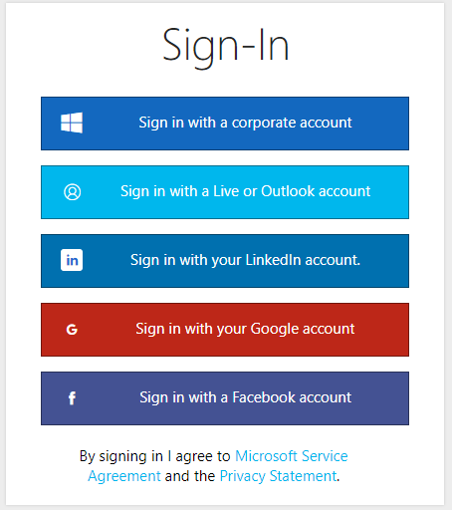

1. **Welcome!** You now have access to the Video Indexer web experience. After logging in you will be dropped into the Video Gallery where you can see all your uploaded videos as well as sample videos. From here you can search in all videos, upload new videos, see insights for each specific video and more.

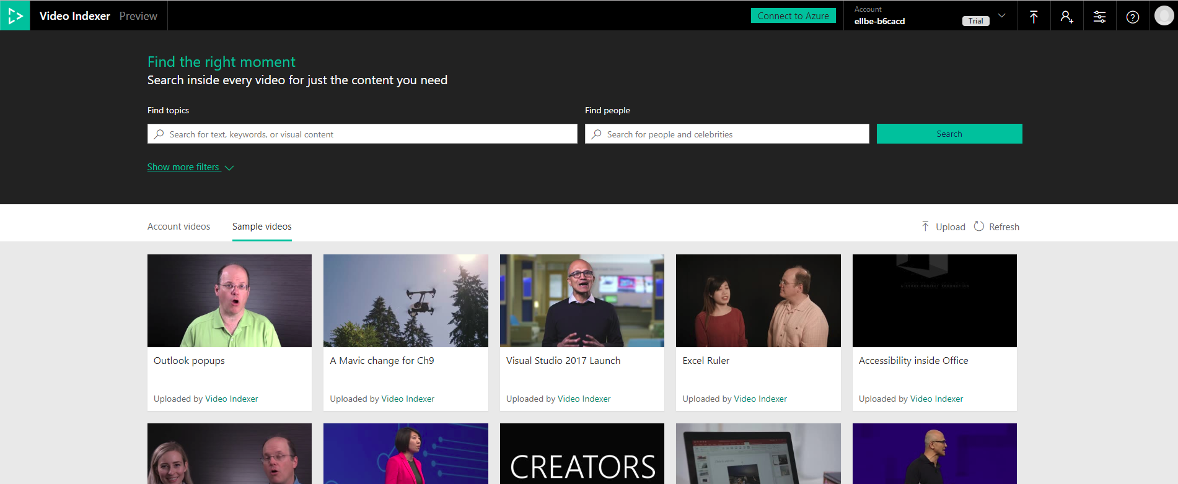

# Exercise 2: Search within existing files

*Duration: 4 minutes*

## Context

* From the Video Indexer portal, you can search for insights on indexed video and audio across your catalog. This includes identifying celebrities, detecting keyworks and labels, finding brands and much more. Let’s start by searching across sample videos that were already indexed for you.

## Steps

1. Click on the “Sample Videos” tab to see all sample videos



1. On the search bar, search for **Build** in the ‘Find topic’ box and for **Satya**in the ‘Find people ‘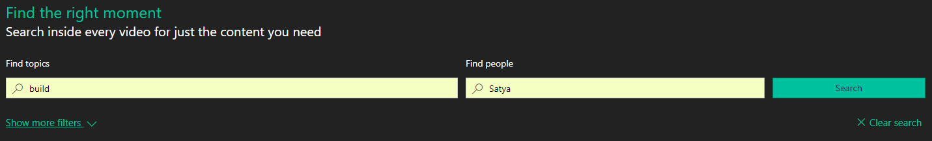
2. The videos in the gallery will are filtered according to your filtering you requested, and each video thumbnail will include a summary of the insights found!

In this case we can see visual, transcript, labels and name insights were found. Later in this workshop we will learn more about those insight.

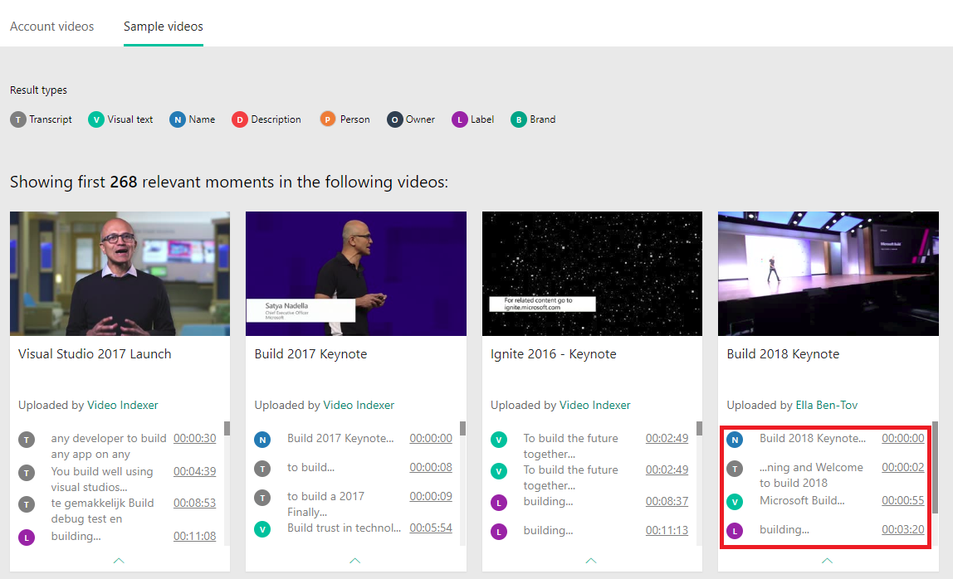

1. Click **show more filters** to see more filtering options such as filtering by specific types of insights or specific languages.
2. Click **Clear search** to start over.

# Exercise 3: Review insights in a file

*Duration: 10 minutes*

## Context

* For each video you can see the cognitive insights found for the video and track them as the video run. This include a broad set of insight types, such as people recognition, celebrity identification, keywords extraction, label extraction, brand identification, sentiment analysis, keyframe analysis and more.
* **Important**: These features represent only a subset of the insights available via the Video Indexer! We will see several options for how to get to more insights later in this workshop (hint: you can download the JSON file or use the API to get more insights)

## Steps

(part of this exercise will require you play a video, we recommend using headphones or mute the sound in your laptop to avoid disturbing other participants)

1. In the **Sample videos** tab hover over the video called “*Build Keynote 2018*”.
2. Click **Play** to go into the video player page

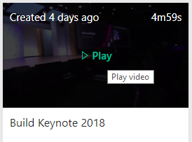

1. In the top of the cognitive insights pane (on the right of the screen), click on **Transcript** to see the video transcript. The transcript includes the voice to text identified by Video Indexer as well as OCRs, people found, sentiment indications and more.



1. Enable the **Autoscroll** toggle on the right to have the transcript scroll as the video progress and the current segment highlighted at any time

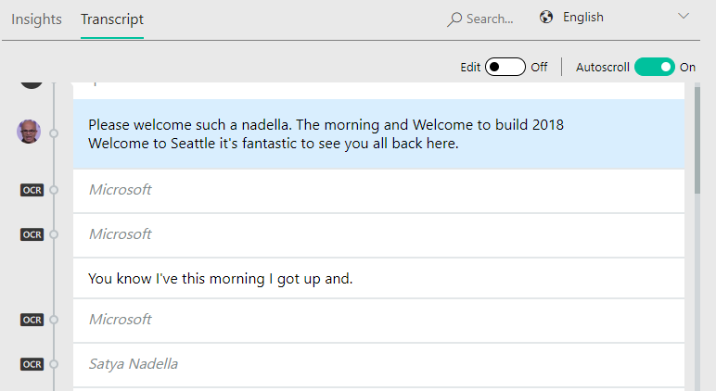

Fun note: you can also see the transcript directly in your layer by choosing to **closed captioning** and then **English** in your player actions.

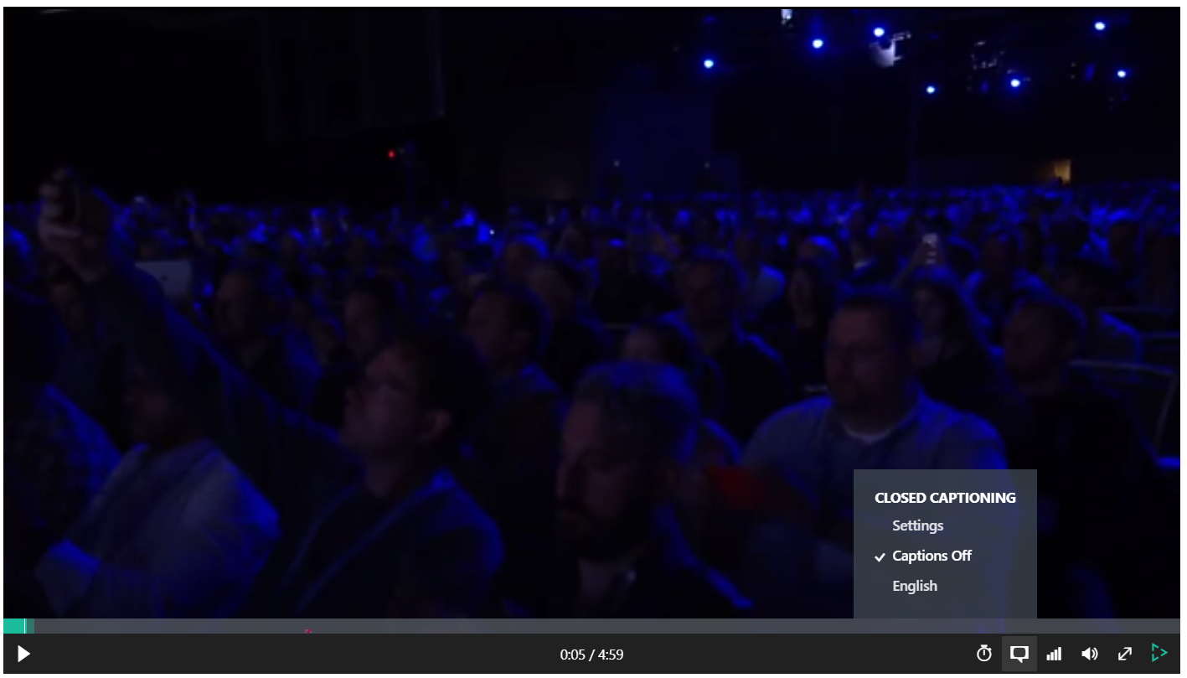

1. Now, let’s explore some of the insights found on this specific video. Click on the **Insights** tab to go back to insights summary.



* 1. **Celebrity Identification**: Video Indexer identified Satya in the video, you can see his name, role and biography, as well as how much time and when he made appearances in the video. Use the left and right arrows to jump between segments he appears in

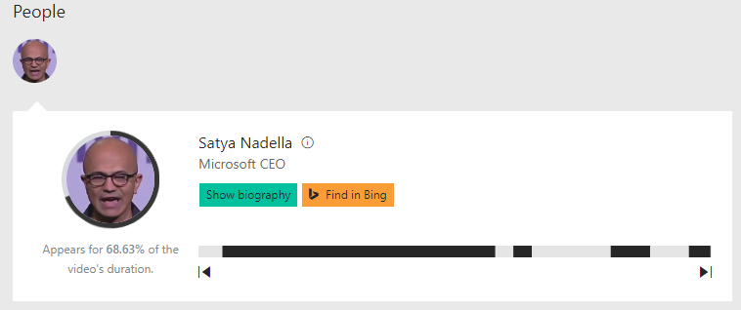

Video indexer is able identify a large set of celebrities (like Satya in this example) out of the box and allows you custom train the model with your own celebrities, by tagging additional faces identified in your uploaded video.

* 1. **Keyword identification**: Video Indexer used the information on the transcript – gathered from the spoken information as well as OCR findings in the video, to identify keywords.

This can help you get the essence of what was discussed in this video. In this case we can see that Satya referred to the *intelligent edge*, *industrial revolution* and more.

Use the **show all** to reveal the full set of keywords found and the right and left arrows to navigate to the specific location in the video where they appeared.

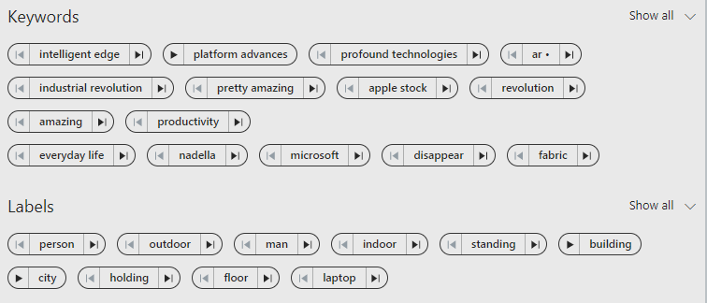

* 1. **Label identification**: Labels are visual findings in the video, they can help you determine elements, scenes, and locations.

In this case, the labels: “*man”, “standing”, “indoor*” really reflect on what we see in the video. As in Keywords, you can use the show more to see the full set of keywords found and to use right and left arrows to navigate to the specific location in the video where they appeared.

Note: you can see that some of the labels are less relevant, for example ‘outdoor’, this is the nature of machine learning algorithms, it is a prediction tool and, in some cases, may be erroneous. In this case probably because this movie was shot in a huge space. However - looking at the labels still gives you a good idea for what this video is about.



* 1. Video Indexer identified two **brands** in this video, that Satya mentioned or appeared as OCR in his keynote: “*Microsoft”* and “*Apple inc.”*. Here is well, use the arrows to jump to the specific location in the video where they appeared and to use show description to see their Wikipedia abstract.

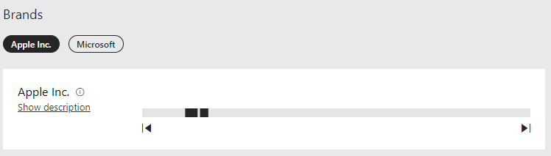

* 1. **Sentiment**: Video Indexer has also identified the different sentiments that appear through the video, click on each segment to see what actually happened in the video to drive that. you can see that oveall (insuprosingly) Satya expressed mostly positive sentiments in his keynote.

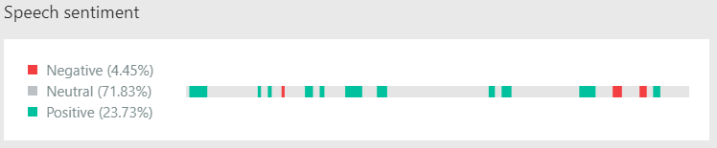

1. **Open the JSON file** by clicking on the **{}** button at the bottom left of the video player.



All this information that you can browse on the widgets comes from a JSON file that it’s what the developer would need to work with if they’re building a custom solution. You will be able to explore the JSON file in more detail in Exercise 8 below.

# Exercise 4: Upload and Index your own file

*Duration: 5 minutes*

## Context

* Video Indexer allow you to upload your own video and audio files
* Once a file is uploaded and indexed, it is added to your catalog and you can search it and review insights on it, like you did in the first step

## Steps

1. Go back to he video catalog by clicking the top right corner of the screen or by clicking back



1. Click the **Upload** button on the top right of your catalog (under the search section)

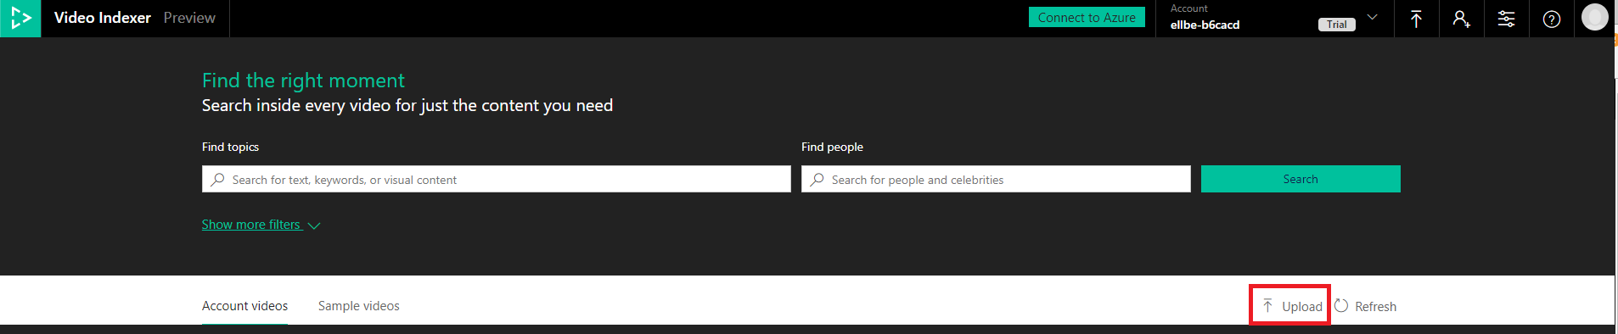

1. Select the **enter file URL** link and enter the following sample URL address: <https://aka.ms/VISampleVideo>

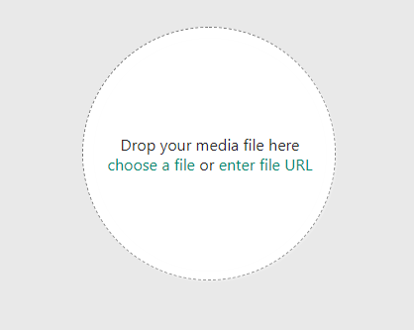

1. Select a ‘video name’ of your choice for your video and Click **Upload**.

The video will start to upload…

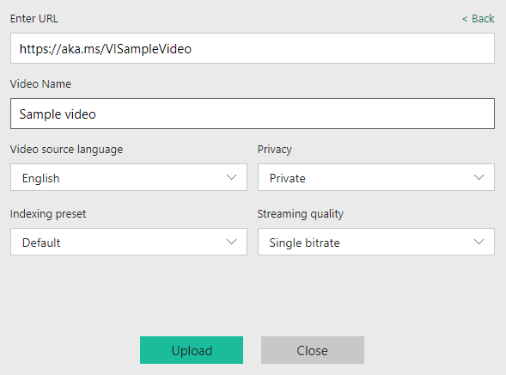

1. The upload may take a few minutes. You can click **Run in the background** to continue browsing your existing videos while the video is uploading
2. Once the video is uploaded it will added to your catalog under the **Account videos** tab and start indexing

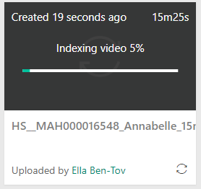

1. **Done!** You have indexed your fist video, you can now explore the insights found for this video in the portal as well as on a JSON file that a developer could parse on a custom development.

Try to explore **- what interesting insights you can find in this video?** 😊

# Exercise 5: Embed widgets on your own website

*Duration: 4 minutes*

## Context

* Video Indexer allows you to create an interactive widget for the insights gathered on your video as well as for the video player itself

## Steps

1. Go back to the “*Build Keynote 2018*”, you reviewed in exercise #3 (in the **Sample videos** tab)
2. Click on the embed (**</>**) icon at the bottom of the video

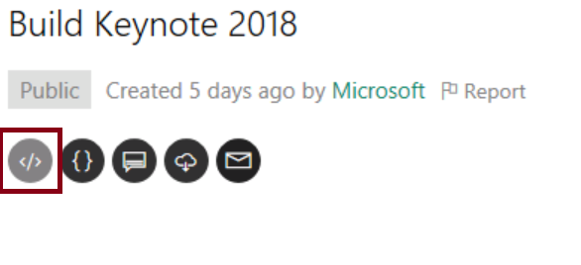

1. A ‘share & embed’ pop up appears, allowing to copy the iframe code to the web site. From here you can choose to create an embedded code for the cognitive insights, the video player or both.

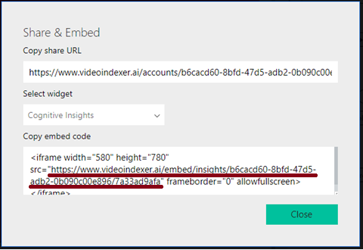

1. Optional: to test the iframe copy the ‘src’ part of the ‘Copy embed code’ section into a new tab in your browser (see highlighted part in the image above)

# Exercise 6: Edit a file

*Duration: 5 minutes*

## Context

* Video Indexer also includes a light weight editor, which makes it is easy to find highlights in a video
* You can filter any insights and then select witch sections in the transcript to edit in and out of the video and then publish it as a new video

## Steps

1. The video you uploaded in exercise #4 should be ready by now! Go back to the catalog and open that video player.

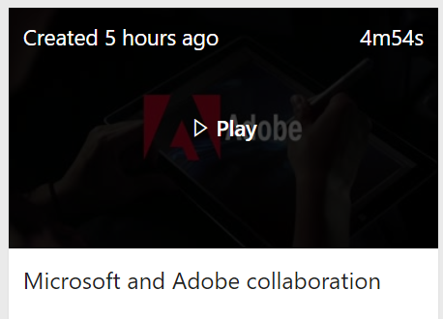

1. Click **Edit** on the bottom right of the file player you uploaded to go to the video editor

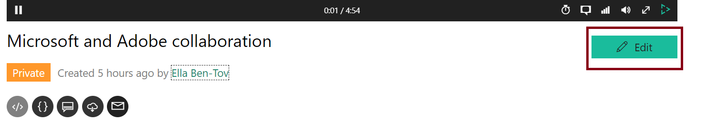

1. In the filter pane on the left-hand side, filter for Keywords = ***business transformation*** and People = ***Satya Nadella*** to create a clip of Satya talking about business transformation

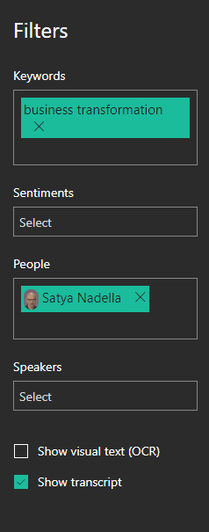

1. The transcript will filter to show only captions that answer your search criteria. Hover on the relevant captions and click the **+** action on the top right of the transcript to select the clip that was filtered

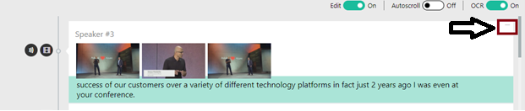

1. Click on the **Preview** button on the right to see your selection result

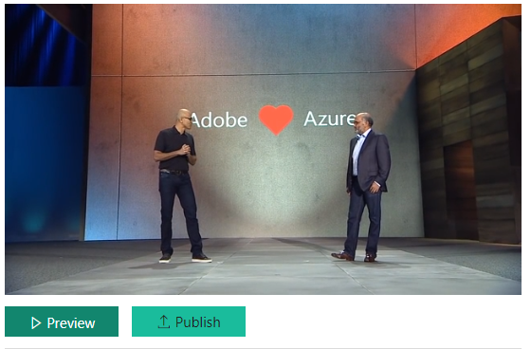

1. Click on the **Publish** button on the right to save your selection as a new video.

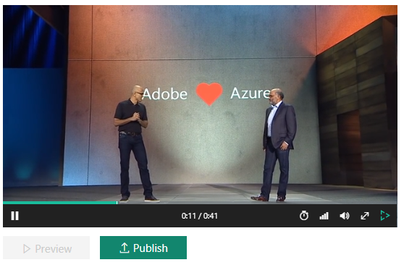

1. A new video that contains a clip from the original video was added to your catalog and start to play!

# Exercise 7: Getting started with Video Indexer REST API

*Duration: 7 minutes*

## Context

* Everything you seen (**and more!**) is available also via the Video Indexer REST API
* Getting started and evaluating the REST API is simple and straight forward and **does not require any coding skill!**
* The Video Indexer rest API is unique in the industry by the fact that it enables you to use it in a client to server architecture (as well as server to server)

## Steps

1. Open a new tab on your browser
2. Go to the API portal <https://api-portal.videoindexer.ai/>.   
   This portal gives you quick and easy access to review and try out the Video Indexer APIs available.
3. You are probably already logged in via SSO but if not, login with the same credentials you logged into the service in exercise #1



1. Select the **APIs** tab



1. Choose **Authorization** to get the token to call the API operations with. Note that this token is valid for one hour.

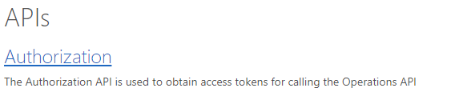

1. Select the **GetAccounts** API call or the left side of the screen

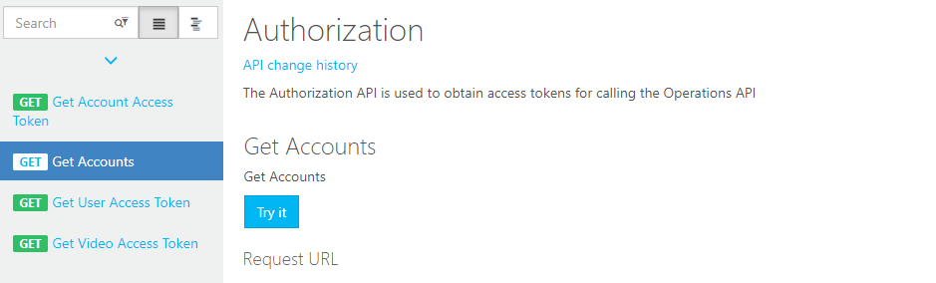

1. click **Try It.**

Clicking ‘try it’ on any API call in this web site, will allow you to try the API call with your own parameters without needing to write any code. In this case, we are trying to get the account information in order to call other operations.



1. Fill in the parameters: *location =* ***trial***, *generateAccessToken=****true***, *allowEdit=****true*** to get access token to the account you used in this workshop

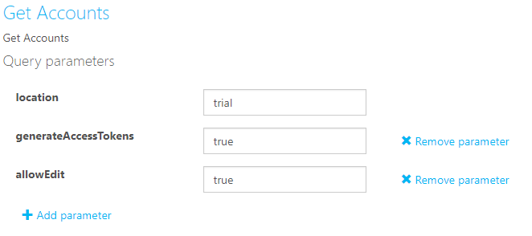

1. Scroll to the bottom of the page and click **Send**



1. In the result you will get your **account id** and **access token**.

**\*\*\*Important\*\*\***: **Copy the account id and access token to a notepad file or keep the result page open as you will need them for later API calls in exercise #8.**

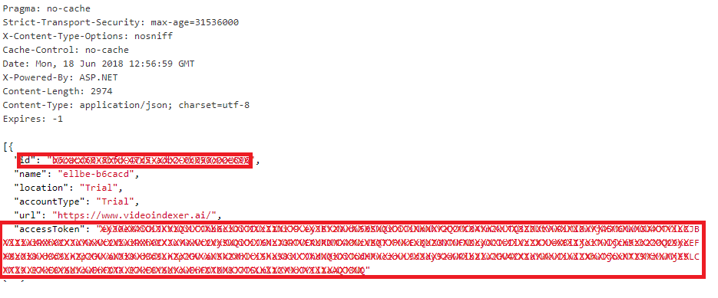

# Exercise 8: Invoke a sample service

*Duration: 7 minutes*

## Context

* Now that you are authorized to the API and have your access token available, you can try out some of the functions…

## Steps

1. Go to the **API** tab again and choose **Operations** to review all the REST API calls available to you in video indexer.

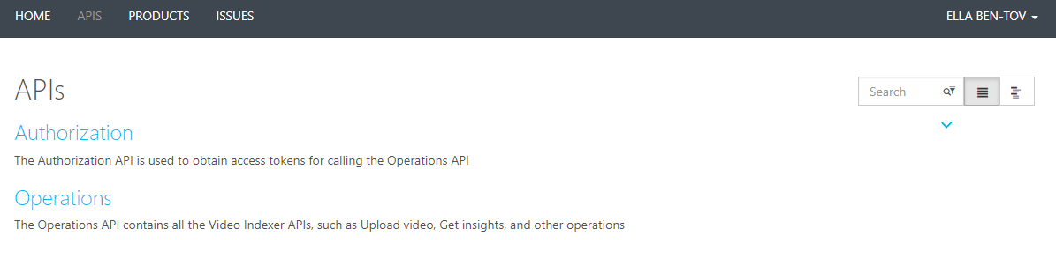

For this workshop, we will use the API to get insights on the same video we uploaded in previous exercise

1. Choose the **ListVideos** API call in the left side of the screen (tip: you can use the search bar on the top to find it)



1. click **Try it** and fill in the parameters: *location =* ***trial*** *and* ***account id*** *and* ***account token*** *from the GetAccountscall* from the previous exercise

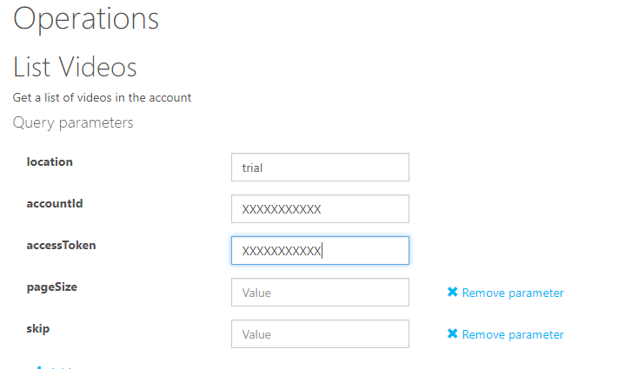

1. Scroll to the bottom of the page and click **Send**
2. Your account first result will include the video that you uploaded in exercise #4.

**\*\*\*Important***: Copy the video id (called” id” in the result) to notepad or keep the result page open as you will need them for later API calls in this exercise**

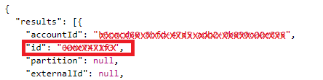

1. Now choose the **GetVideoIndex** call in the left side of the screen



1. click **Try it** and fill in the parameters:
   1. *location =* ***trial*** *and*
   2. **account id** from the *GetAccounts* call result
   3. **account token**from the *GetAccounts* call result
   4. **video Id** from *ListVideos call* result

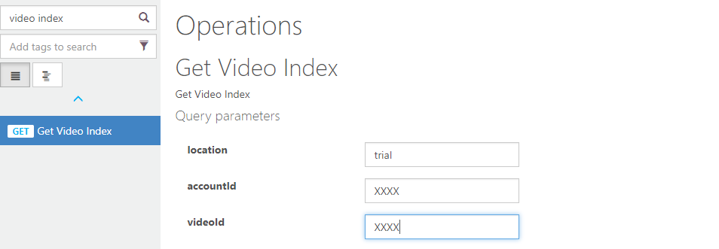

1. Scroll to the bottom of the page and click **Send**
2. The result will be in JSON format and includes all the insights found on the Video.

Some insights in this result are not yet available in the Service. You can use search for some examples in the response:

* 1. Search for “*visualContentModeration*” and “t*extualContentModeration*” to find content moderation insights results

**Content moderations insights** allow you to find and alert on inappropriate or offensive content in your videos.

* 1. Search for “*keyFrames*” to find keyFrame results

**Keyframe insights** allow you to identify still images representing scenes in videos, to be later used for thumbnails, or clips representing the video

Congratulations!

You successfully completed the Video Indexer workshop!

We hope you have enjoyed this workshop, as you can imagine this is just the tip of the iceberg, visit **http://video.ai** if you want to continue learning about Video Indexer and Video AI.